Acceptance

This document is being prepared for capturing the detailed description of customization required in the main workflow for Contract Service Module in Retail Product Line mentioned therein and the proposed solution for the same for Islamic Banking.

For Tamweel Aloula

Reviewed By | Approved By

We agree that this document overrides any other documents that have been shared previously.

Version Control

Version No | Date | Summary of Change | Impacted Sections & Page Numbers

Contents
1. Introduction 4
2. Scope 4
3. Business Requirement 4
3.1 Business Process 5
3.2 Field List for Digital 7
3.3 BRD Document for Service Module 7
3.4 Workflow 8

Introduction
This document presents the introduction of the Service module within the Digital Channel platform, focusing on key services: Service Module , Customer Info, Change Customer Info. These services are designed to empower customers with greater flexibility in managing their financial obligations through a seamless digital experience.
The integration with the Core system ensures real-time processing, accurate data flow, and improved operational efficiency across all service touchpoints.

Scope
The scope of this document is limited to additional changes & modification brought in the product as per business need.

Business Requirement
Below is the list of service required to be configured in digital channel:
- Customer Info ---All Product--Wahab
- Change Customer Info—All Product—Wahab / Ali Fayaz
- Financial Dashboard------ All Product---Kashif /Farhan Ul /Affan
- Early Settlement ---- All Product---Kashif /Farhan Ul /Affan
- Partial Settlement ---- All Product---Kashif /Farhan Ul /Affan
- Top up---- All Product---Kashif /Farhan Ul/Affan--
- Restructure ---- All Product---Kashif /Farhan Ul /Affan
- Buy Out---- All Product---Kashif /Farhan Ul /Affan
- Loan Transfer------ Ijarah---Kashif /Farhan Ul /Affan`
- Advance payment ------ All Product---Kashif /Farhan Ul /Affan
- Adhoc Payment ---- All Product---Kashif /Farhan Ul /Affan
- Loan Cancellation (Withing Cooling Period) ----- Tawaruq---Kashif /Farhan Ul /Affan

Business Process
- Customer Info (Profile):
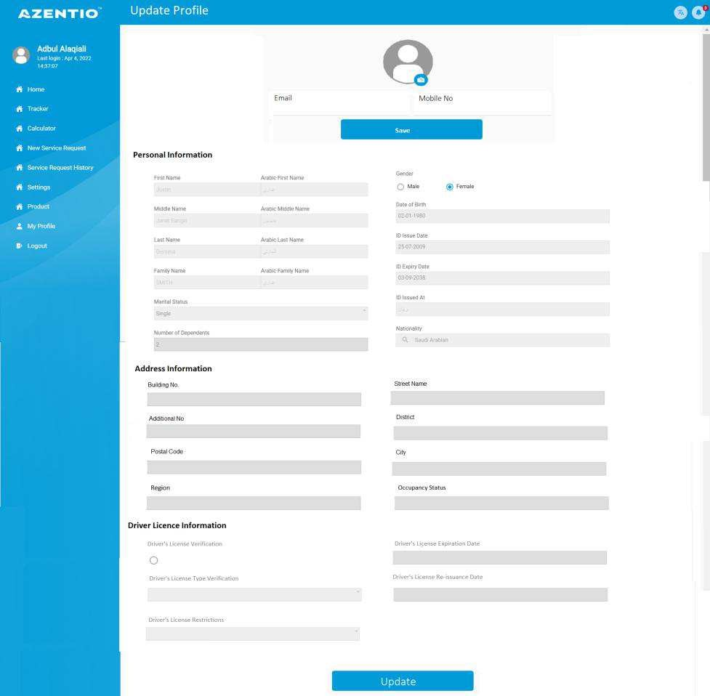
  - Once the customer logins in the digital channel customer can view its Demographic & Active contracts, the user will click on the contract no and all the details will be visible to him as per the contracts. Below is the Dummy screen attach for reference.
  - The contract detail will be visible once the user clicks on the contract no, the contract details will be fetched from Core system the data will be the next payment date, no of installment paid , current outstanding, etc.
below is the SS attach for reference.
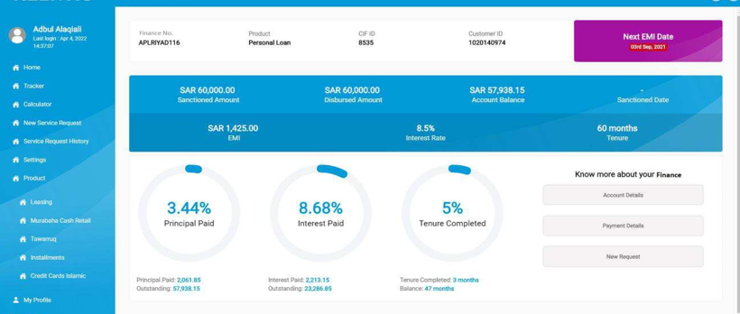

- Change Customer Info
  - The user can change and update the Demographic detail by clicking on Update button provided in the information which needs to be update.

  - The updated demographic detail should be visible in the core system.
- Service Module
  - There will be the service module tab given in the Digital application where user will have option to select the type of service which he wants to opt for from the given dropdown list.
The dropdown list will contain
- Early settlement
- Partial Payment
- Restructure
- Top Up
- Loan Transfer
Below is the Dummy SS for reference,
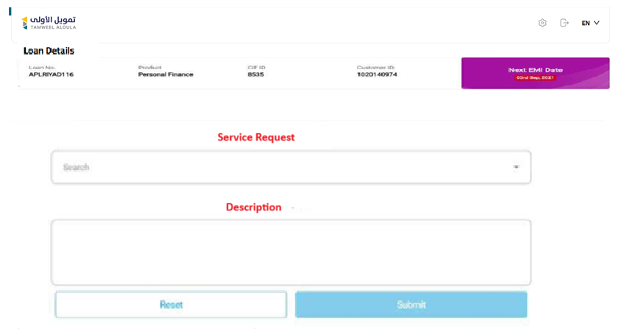

For Early settlement the user will selects the option of Early settlement from the New digital and add the description If required , post submit the request will be triggered to core system where core system will calculate the Early settlement amount and it will be displayed in Digital system.
Please Note : For the Early settlement the ND system should display all the amount calculated in the core system, Similarly for partial payment.
Note : For Buy Out it will be the new journey and user has to select the Product (Tawaruq/ Ijarah) and Sub product as Buy out.
Below is the Dummy SS for reference.
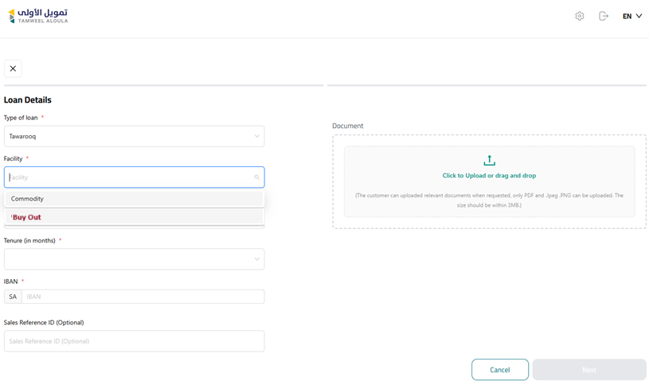

Field List for Digital

BRD Document for Service Module

Workflow
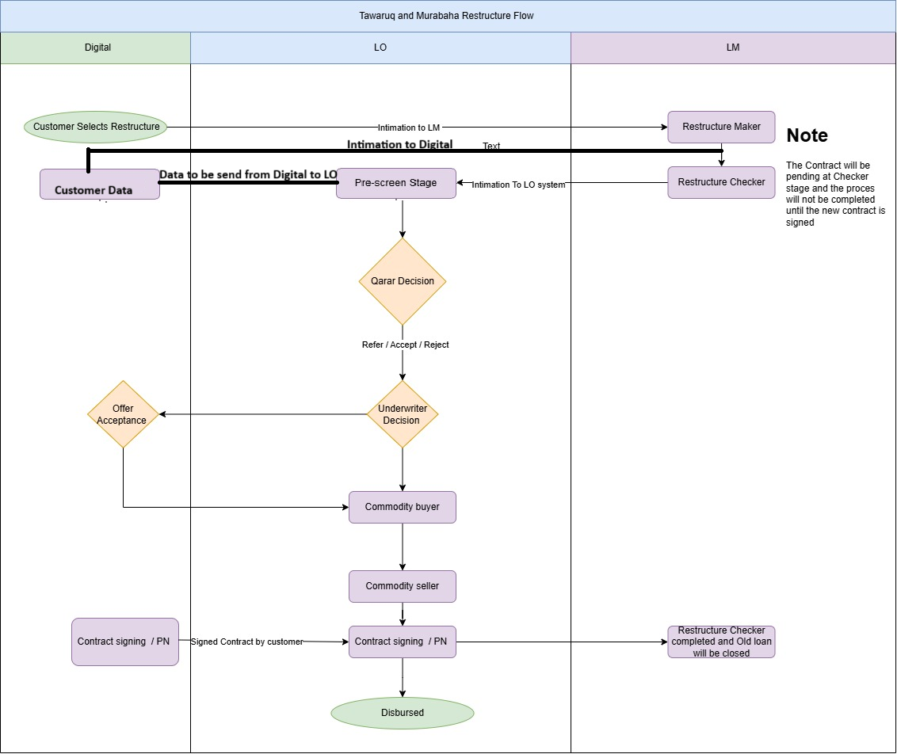

Loan Transfer Workflow

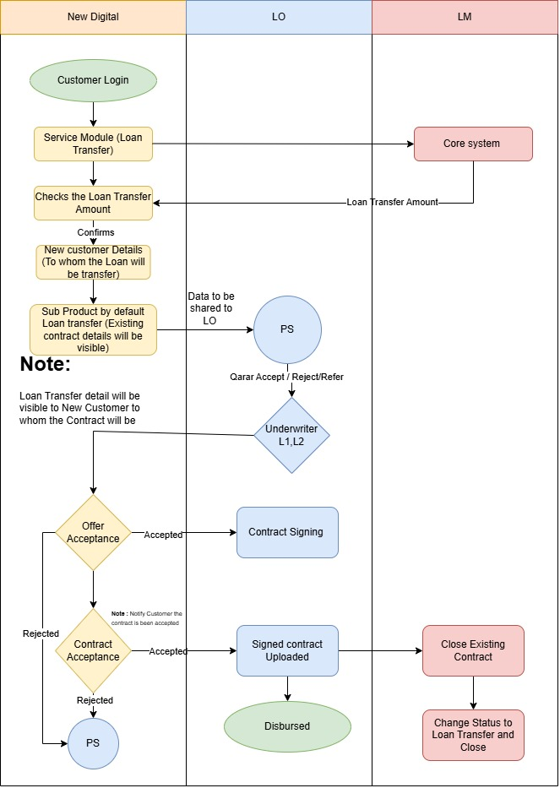ss

